WebLogLoader Service Example of a Windows NT Service
that batch loads data into Innovator



Document #: DOC.8.0.103106

Version 1.1

Aras Corporation
© 2006 Aras Corporation. All rights reserved

Aras Corporation
Heritage Place
439 South Union Street
Lawrence, MA 01843

Phone: 978-691-8900
Fax: 978-794-9826

E-mail: info@aras.com
Website: http://www.aras.com

Notice of Rights
All rights reserved. Aras Corporation (Aras) owns this document. No part of this document may be reproduced or transmitted in any form by any means, electronic, mechanical, photocopying, recording, or otherwise, without the prior written permission of Innovator and other Aras product names and logos are trademarks of Aras Corporation.

Notice of Liability
The information contained in this document is distributed on an “As Is” basis, without warranty. While every precaution has been taken in the preparation of this document, Aras shall have no liability to any person or entity with respect to any loss or damage caused or alleged to be caused directly or indirectly by the information contained in this document or by the software or hardware products described in it.

Table of Contents

1 Send Us Your Comments 5
2 Overview 6
2.1 Components 6
3 Installation and Configuration 7
3.1 Installation 7
3.2 Configuration 7
3.2.1 Innovator Server Connection Properties: 8
3.2.2 Innovator Service Operating Properties: 8
3.3 Event Monitor 8

Send Us Your Comments
Aras Corporation welcomes your comments and suggestions on the quality and usefulness of this document. Your input is an important part of the information used for future revisions.
- Did you find any errors?
- Is the information clearly presented?
- Do you need more information? If so, where and what level of detail?
- Are the examples correct? Do you need more examples?
- What features did you like most?

If you find any errors or have any other suggestions for improvement, please indicate the document title, and the chapter, section, and page number (if available).

You can send comments to us in the following ways:
- FAX:
978-794-9826
Attn: Aras Support
Or,
- Postal service:
Aras Corporation
Heritage Place
439 South Union Street
Lawrence, MA 01843
Or,
- Email:
support@aras.com
Subject Line: Innovator Documentation

If you would like a reply, please give your name, address, telephone number, and (optionally) electronic mail address.
If you have usage issues with the software, please contact your local Aras Account Executive.

Overview

The WebLogLoader Service is a Windows executable program that runs as a Windows Service (see screen shot). This is an example of a service that runs in the background, watching a specified folder, and when data appears in the folder, it is batchloaded into Innovator.

The connection to Innovator is made as a Web Service, using an XM config file stored in c:\windows\systems32 to specify URL’s and connection parameters.

The example, as written, watches for a file named Visitor.Log to be created in c:\inetpub\logs folder (in our case this has web site visit information stored in it). The contents of the Visitor.log are loaded into an ItemType and a RelationshipType within Innovator.

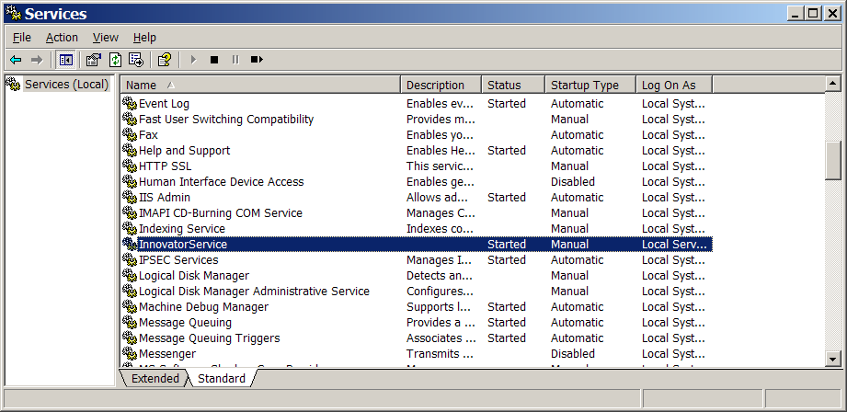

Components

Run-time Components
WebLogLoaderService.exe Windows executable program
InstallService.bat Batch file to install the Innovator Service
UnInstallService.bat Batch file to un-install the Innovator Service
WebLogLoaderServcice.xml Configuration file
NOTE: The WebLogLoaderService example requires Innovator 7.2 and higher.
Development Components
This Zip file also contains the Visual Studio .NET C# project source code and build instructions

Installation and Configuration

Installation
1) Copy the file WebLogLoaderService.xml into the Windows System32 folder ( typically c:\Windows\System32 on XP and 2003, and c:\Winnt\System32 on Windows 2000).

2) Copy the WebLogLoaderService.exe file and the two BAT files into any Folder. For convenience, the root folder of the Innovator web server is recommended.

3) In the Folder selected in step 2, run the BAT file InstallService.bat. This program runs the standard .NET utility named INSTALLUTIL. This program will leave a set of .NET log files in the working directory which should be checked for error messages, and then deleted. If you get an error here, make sure (1) you have the .NET SDK on your machine and (2) the path to C:\Windows\NET Framework\1.1 etc is part of the PATH available to the DOS shell.

4) Verify that the Windows Service named “WebLogLoader Service” was added to the management console (see screen shot above). Specify whether the service should be started automatically or manually.

5) Edit the configuration file (see below) and then start the service.

NOTE: Starting and stopping the InnovatorService can be done using the Windows management console, or in a DOS command Window:

NET START WEBLOGLOADERSERVICE

NET STOP WEBLOGLOADERSERVICE

Configuration
The WebLogLoaderService.xml file needs to be edited to your local parameters. Note that the connection to the Innovator server is made using Web Services, so the program and your Innovator server can run on separate machines.

Example configuration file:

<?xml version="1.0" encoding="utf-8" ?>
<WebLogLoaderService>
<server>http://{yourhostname}/Innovator800</server>
<database>{yourDBname</database>
<username>{logon user account}</username>
<password>{plain text password}</password>
<eventLoggingLevel>4</eventLoggingLevel>
<intervalMinutes>2</intervalMinutes>
</WebLogLoaderService>

Innovator Server Connection Properties:

<server> is the HTTP url of the server. This is the same url that end-users use to run the standard Innovator client

Example <server>HTTP:// http://PLMServer01/Innovator</server>

<database> is the ID of the database in the InnovatorServerConfig.xml. Note that this string is case sensitive.

Example: <database>Production</database>

<username> is the login account that should be used for running the Methods.

Example: <username>admin</username>

<password> is the password for the login account, in plain-text.

Example: <password>innovator</password>

Innovator Service Operating Properties:
Two tags are used to control the behavior of the running WebLogLoaderService process:

<eventLoggingLevel> sets the level of detail for messages that are sent to the Windows Event monitor.

Examples: <eventLoggingLevel>0</eventLoggingLevel> Service startup announcement and error messages from Innovator only
<eventLoggingLevel>1</eventLoggingLevel> Announces the start of every run
<eventLoggingLevel>2</eventLoggingLevel> Detailed reporting of every run cycle.

<intervalMinutes> sets the Windows timer to control how often the WebLogLoaderService is start and the <job> timing logic is tested Any value from 1 to 60 is supported.

Examples: <intervalMinutes>1</ intervalMinutes> Service is run every minute (recommended setting)

Event Monitor
The standard Windows Event Monitor is used for logging. WebLogLoaderService will log startup and shutdown messages. All error messages returned by the Innovator Connection, or by the Methods are also logged to the Event Monitor.

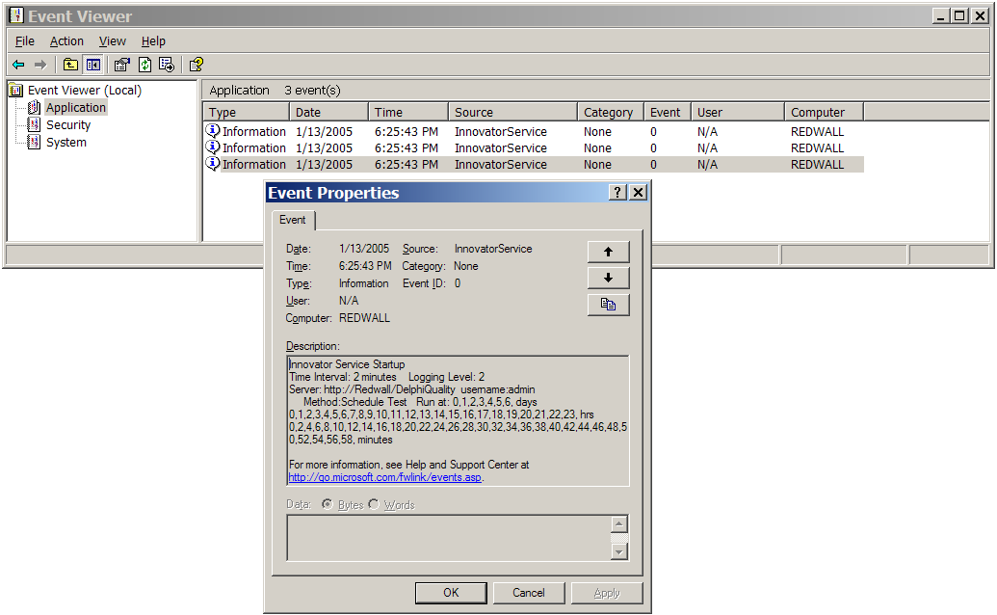

The level of logging information displayed is configured in the WebLogLoaderService.xml file.

